# Arch Linux Installation and Setup Report

Name: Karim Haidari

Course System Administration – Arch Linux

Instructor: Codi West

Project: Arch Installation (Part A & B)

Date: November 9, 2025

## Installation Process Summary

The Arch Linux installation was completed using the archlinux-aarch64.iso image. Disk was partitioned, the ext4 filesystem was configured, and the base system was installed. After enabling NetworkManager and installing GRUB as the bootloader, the system successfully rebooted into Arch Linux. A new user 'Karim' was added to the wheel group, and the GNOME desktop environment was installed and configured.

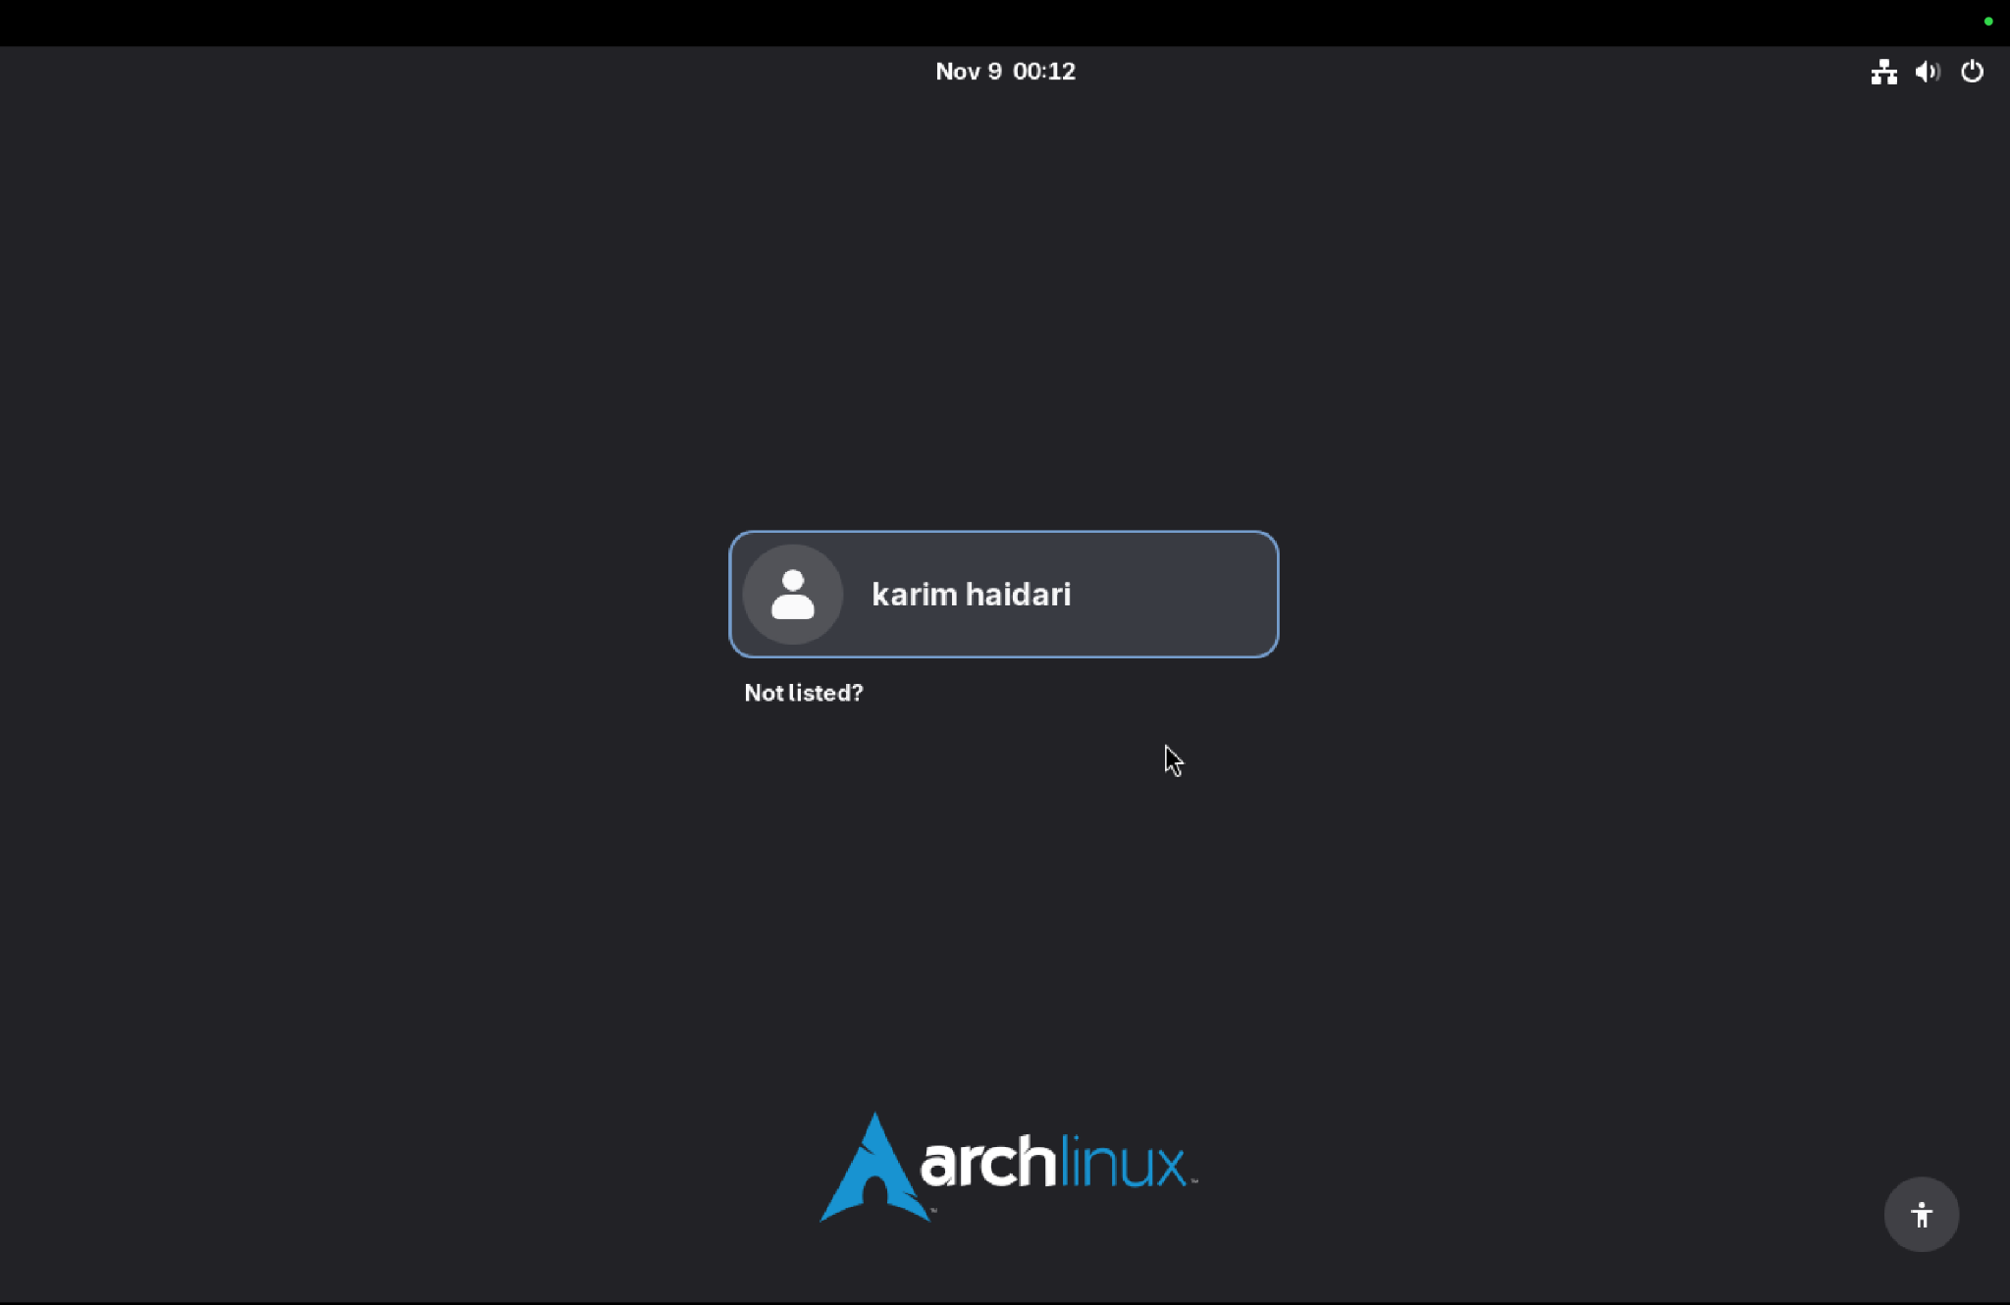

Figure 1: Arch Linux login screen showing successful user creation and GNOME login prompt.

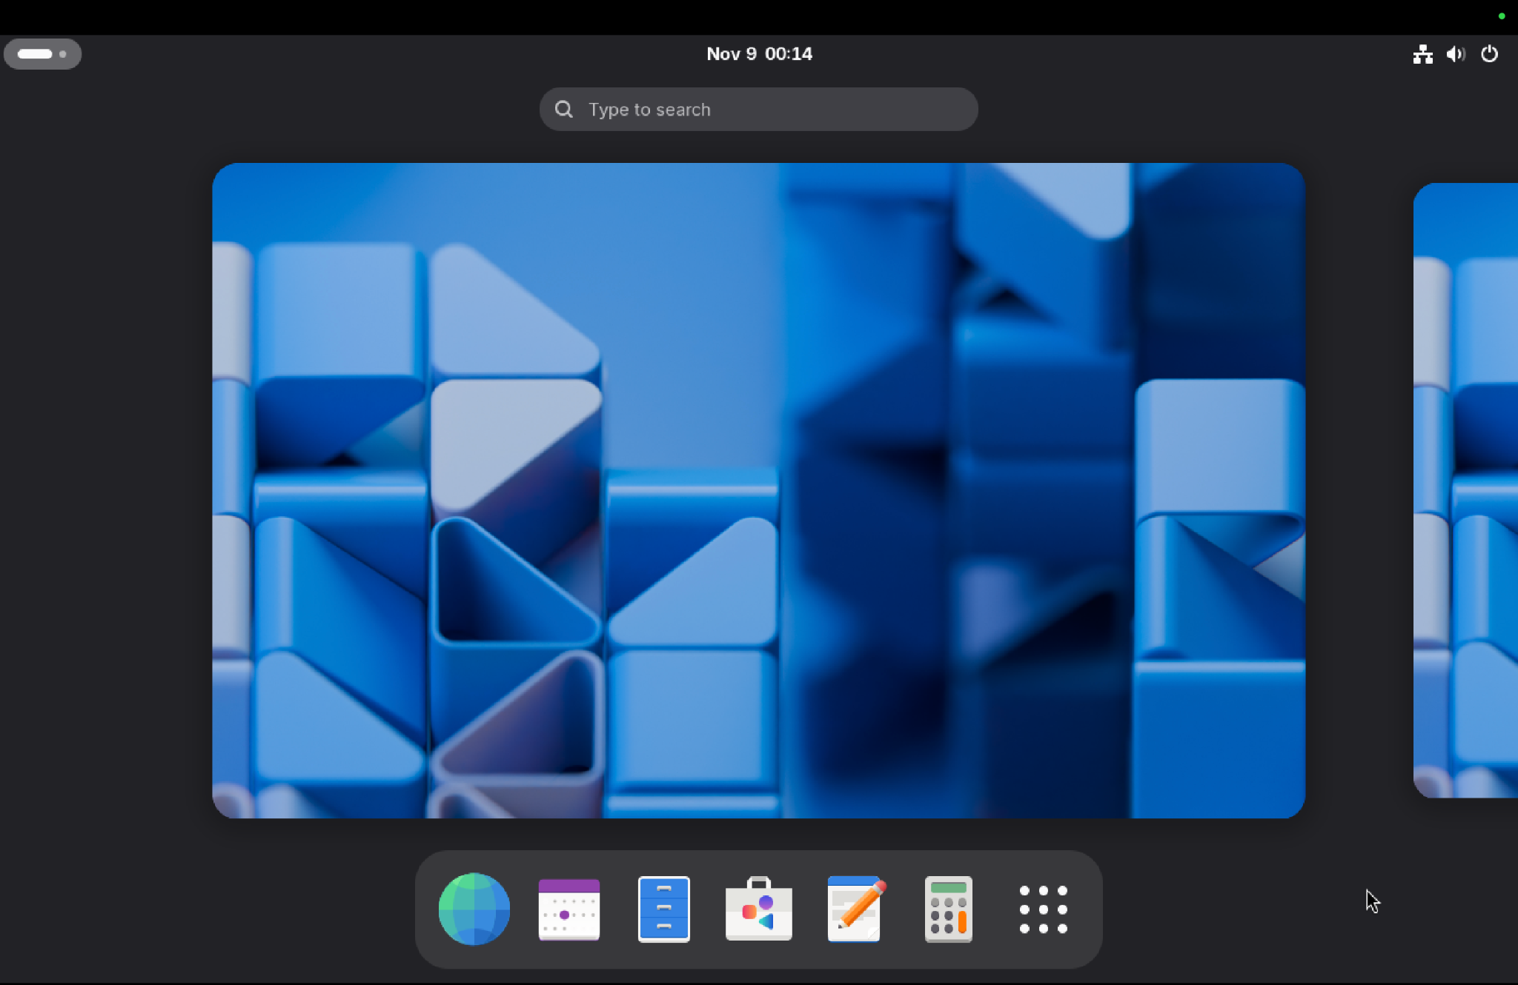

Figure 2: GNOME desktop successfully loaded after first boot, showing icons and panels.

## Network Connectivity Test

To verify network functionality, a ping test to google.com was performed. The results show packets successfully transmitted and received, confirming the virtual machine’s internet connection.

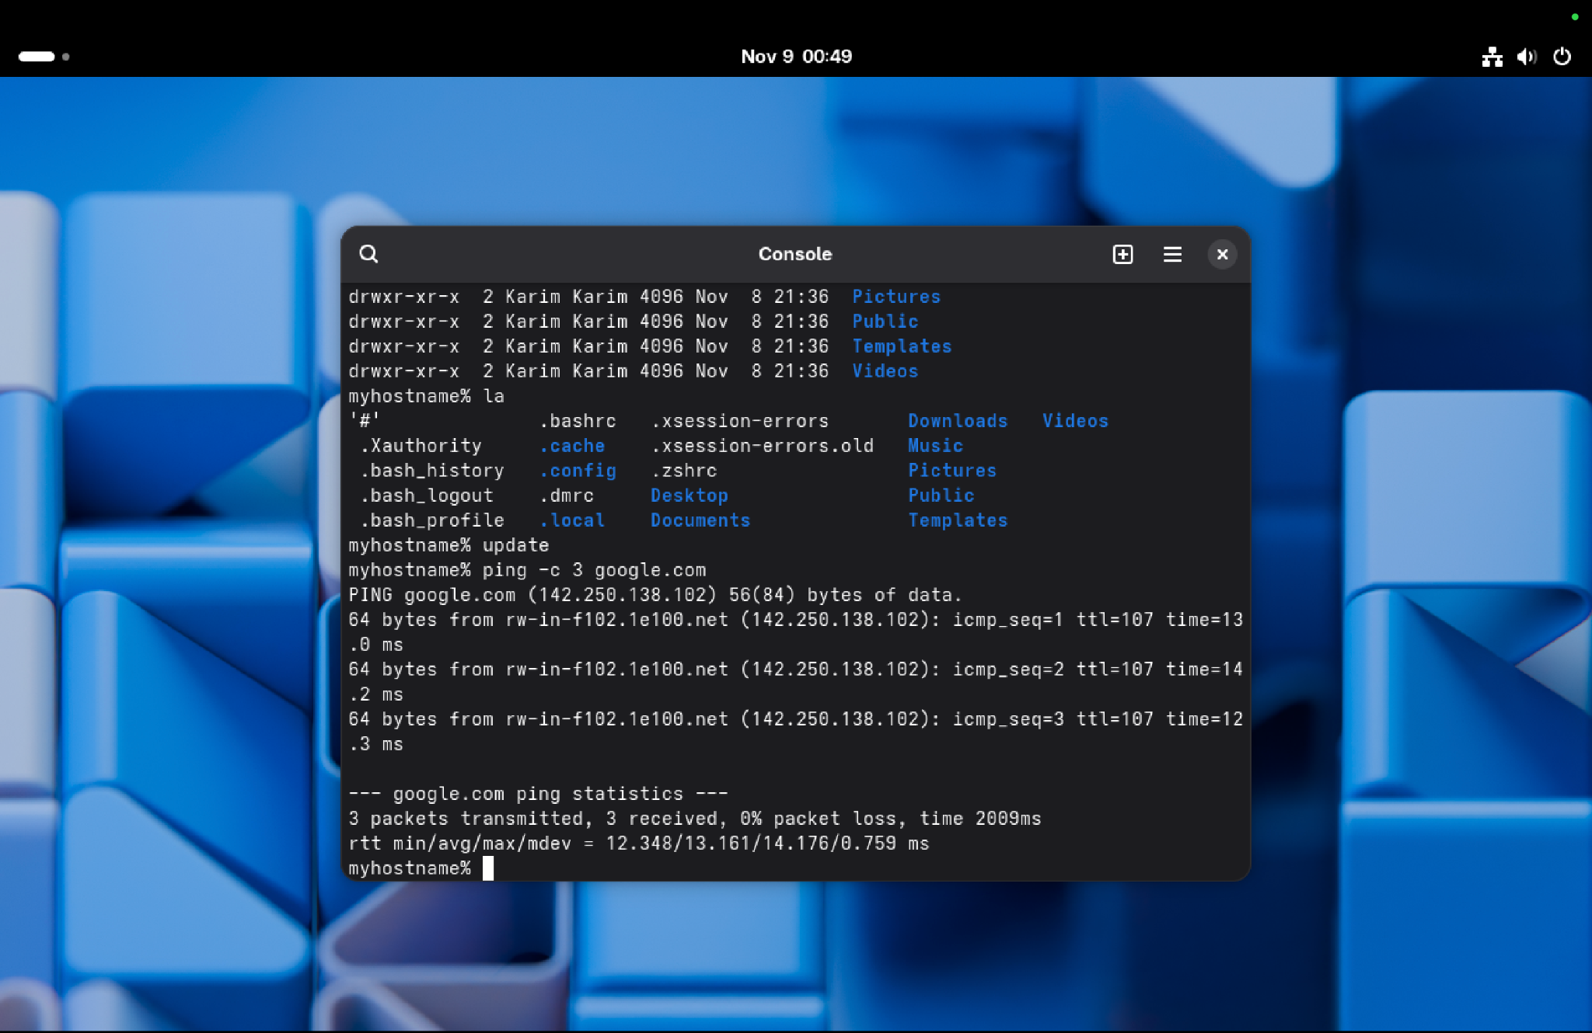

Figure 3: Successful ping test to google.com showing network connectivity.

## System Information (Neofetch)

Neofetch was installed from the AUR using git clone and makepkg commands. The display confirms OS details, GNOME version, kernel version, and system resources.

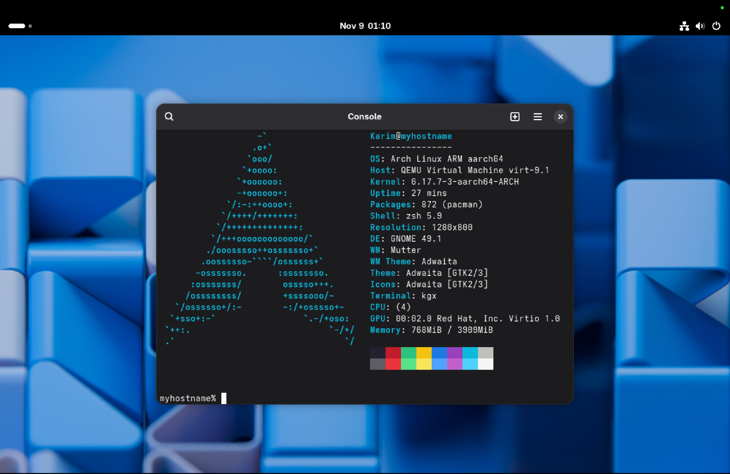

Figure 4: Neofetch output confirming Arch Linux ARM environment and GNOME setup.

## Aliases Configuration

Custom shell aliases were configured in the ~/.zshrc file to simplify frequent commands like 'ls', 'update', and 'clear'. These were verified by reloading the shell and executing the aliases.

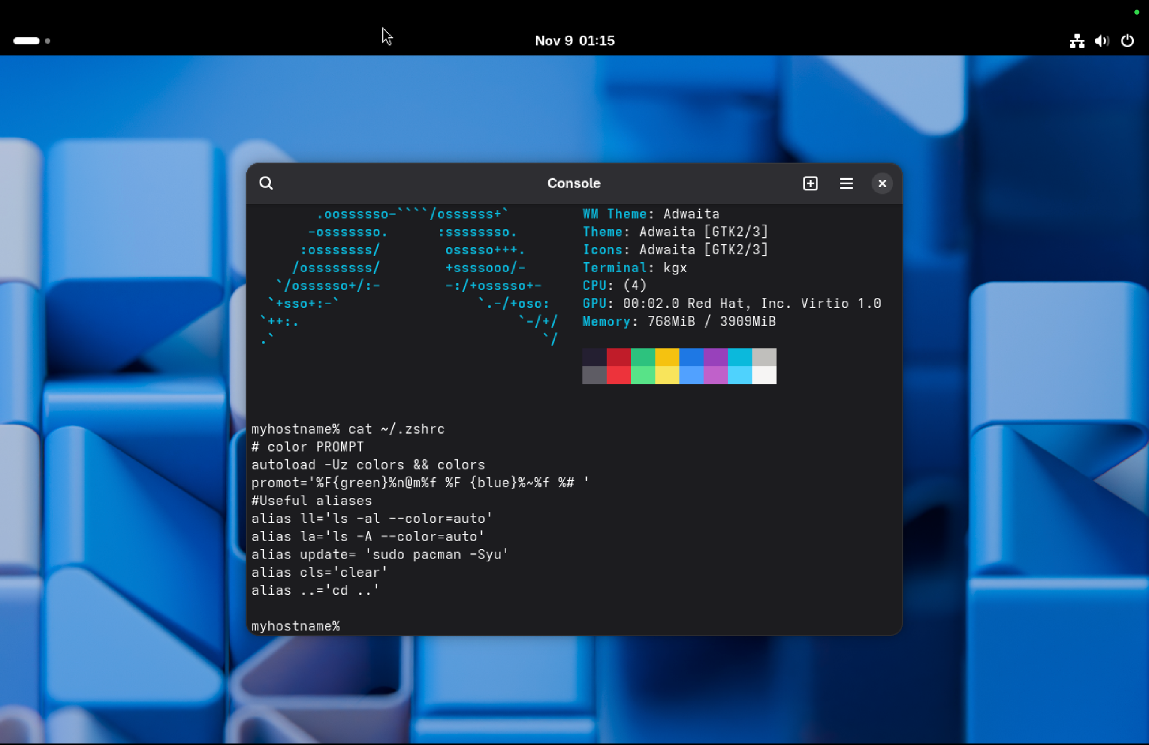

Figure 5: .zshrc configuration showing useful aliases for everyday commands.

## Network Configuration

Using the 'ip addr' command, the assigned IP address and network interfaces were verified. The VM successfully obtained an IP in the 192.168.x.x range.

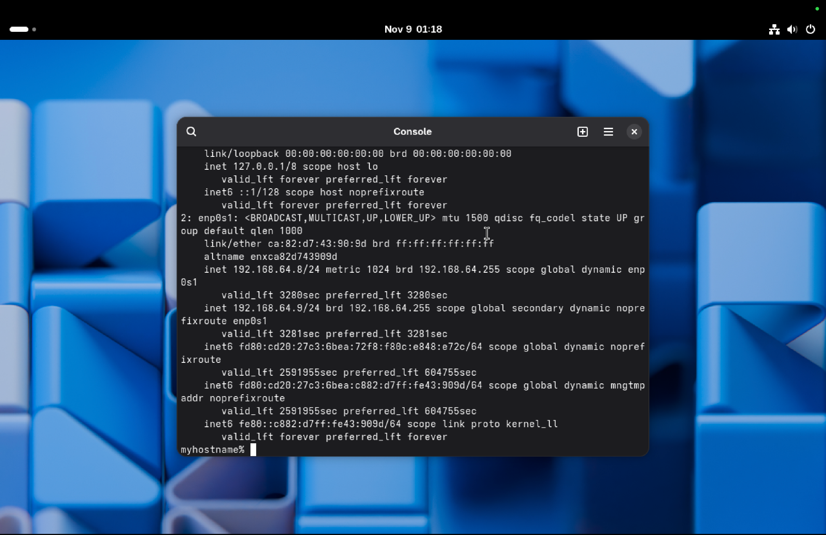

Figure 6: Network interface configuration showing active IP address.

## Users and Permissions

The /etc/passwd file was reviewed to confirm the presence of user 'Karim' along with standard system accounts. Additionally, the sudoers file was configured to allow the wheel group administrative access.

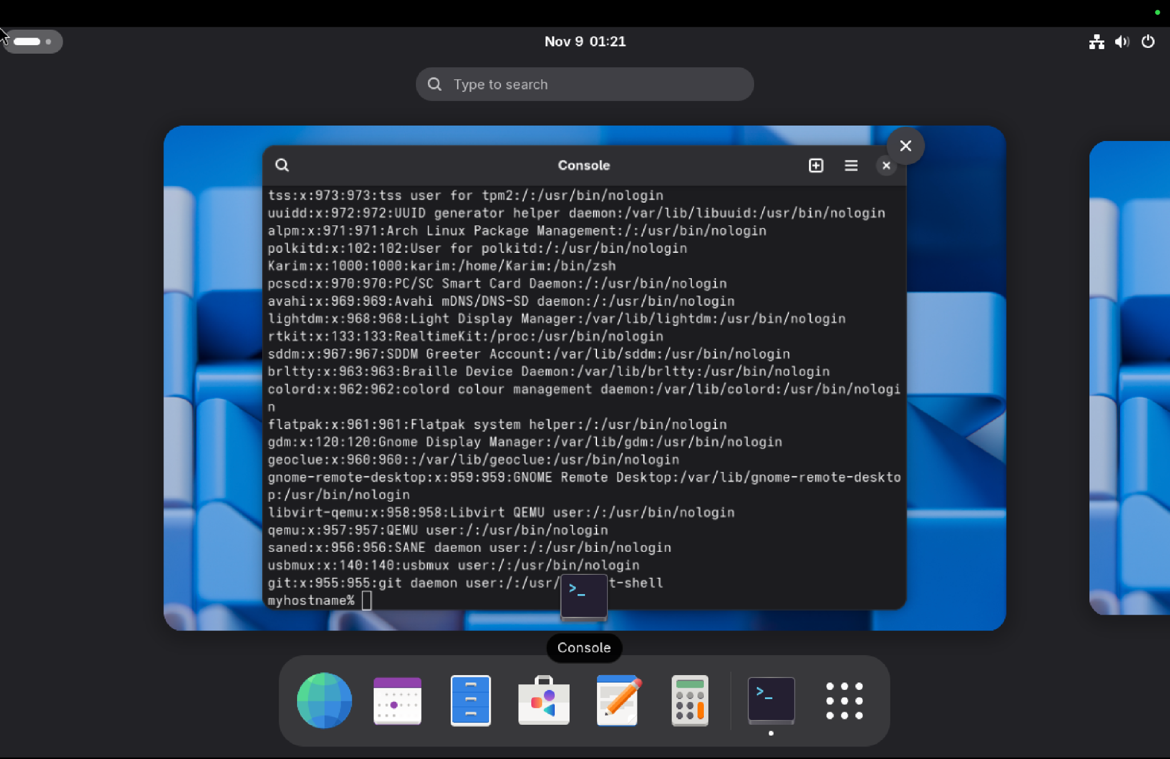

Figure 7: List of all system users including 'Karim'.

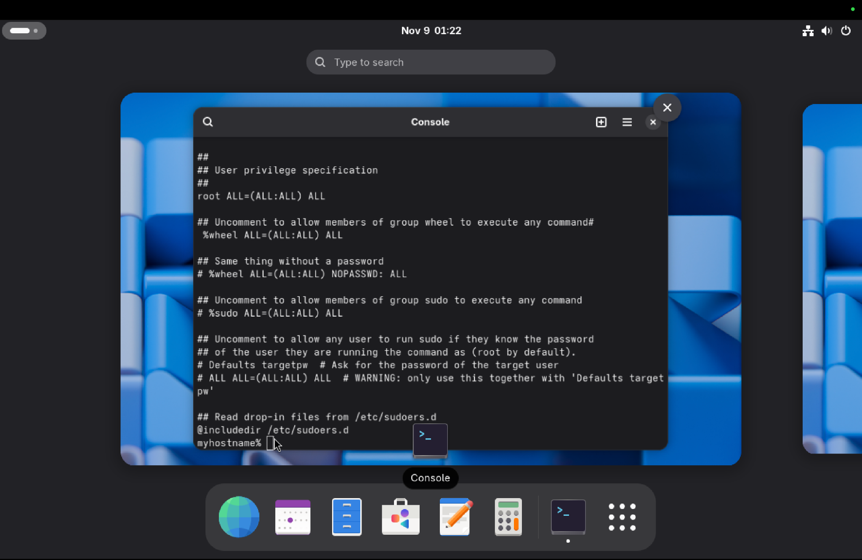

Figure 8: Sudoers configuration allowing wheel group full privileges.

## File and Directory Listing

The home directory structure was verified using 'ls -al' and 'la' aliases, showing hidden configuration files and directories.

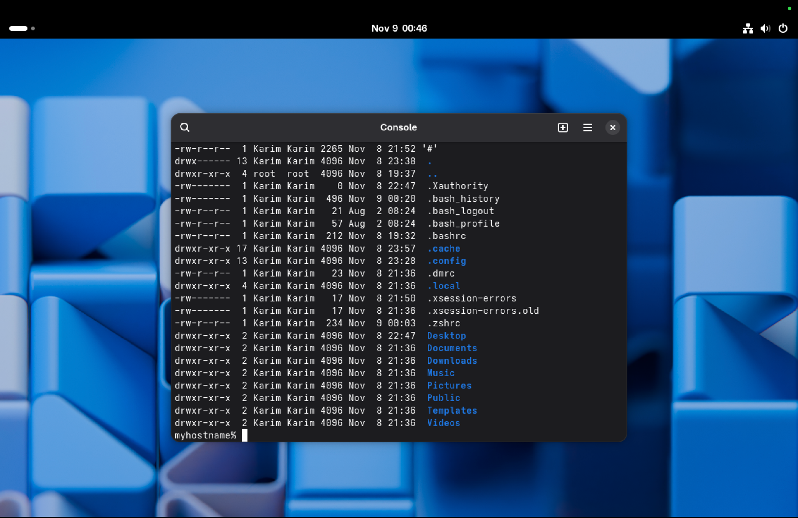

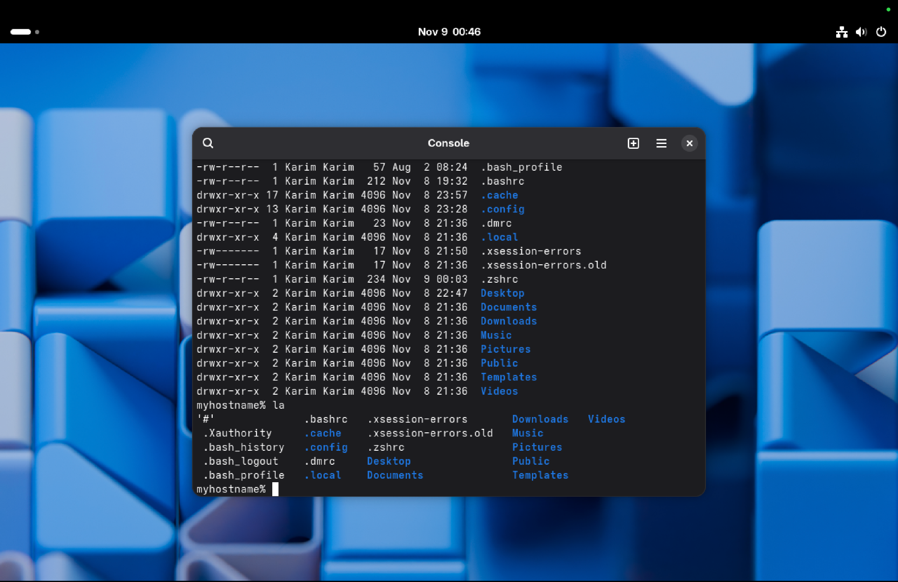

Figure 9–10: Home directory listing showing hidden and standard files.

Below is a screenshot of my .zshrc configuration, showing the color-coded prompt setup using Zsh. This includes enabling color support, enabling prompt substitution, and defining the custom PS1 prompt with green username/hostname and blue directory.

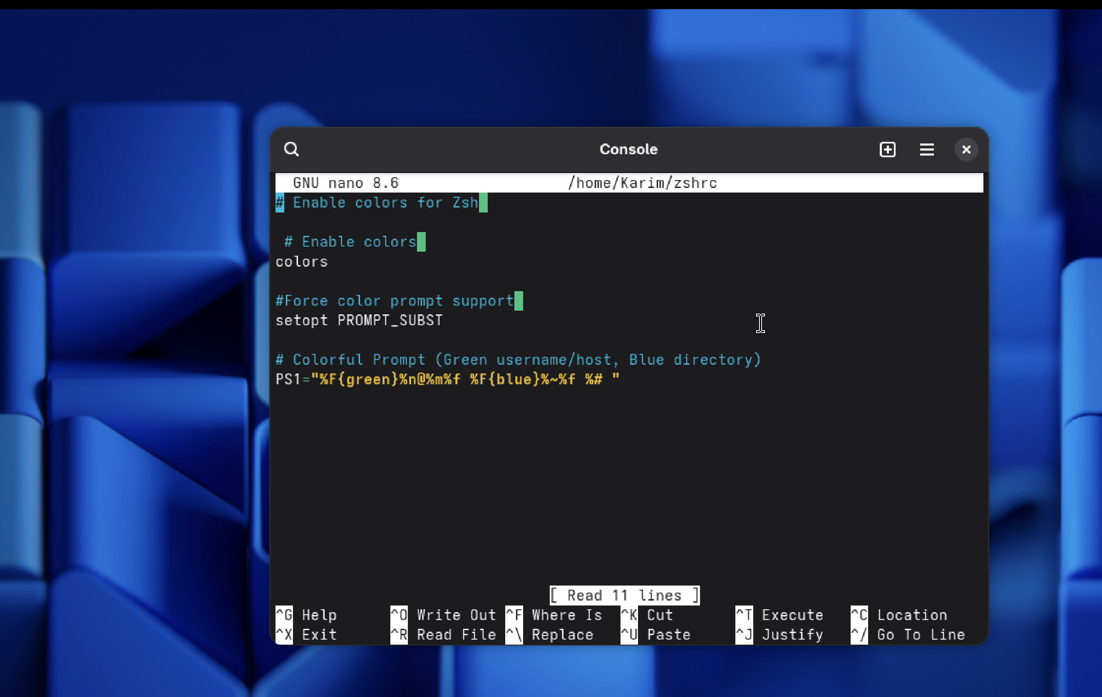

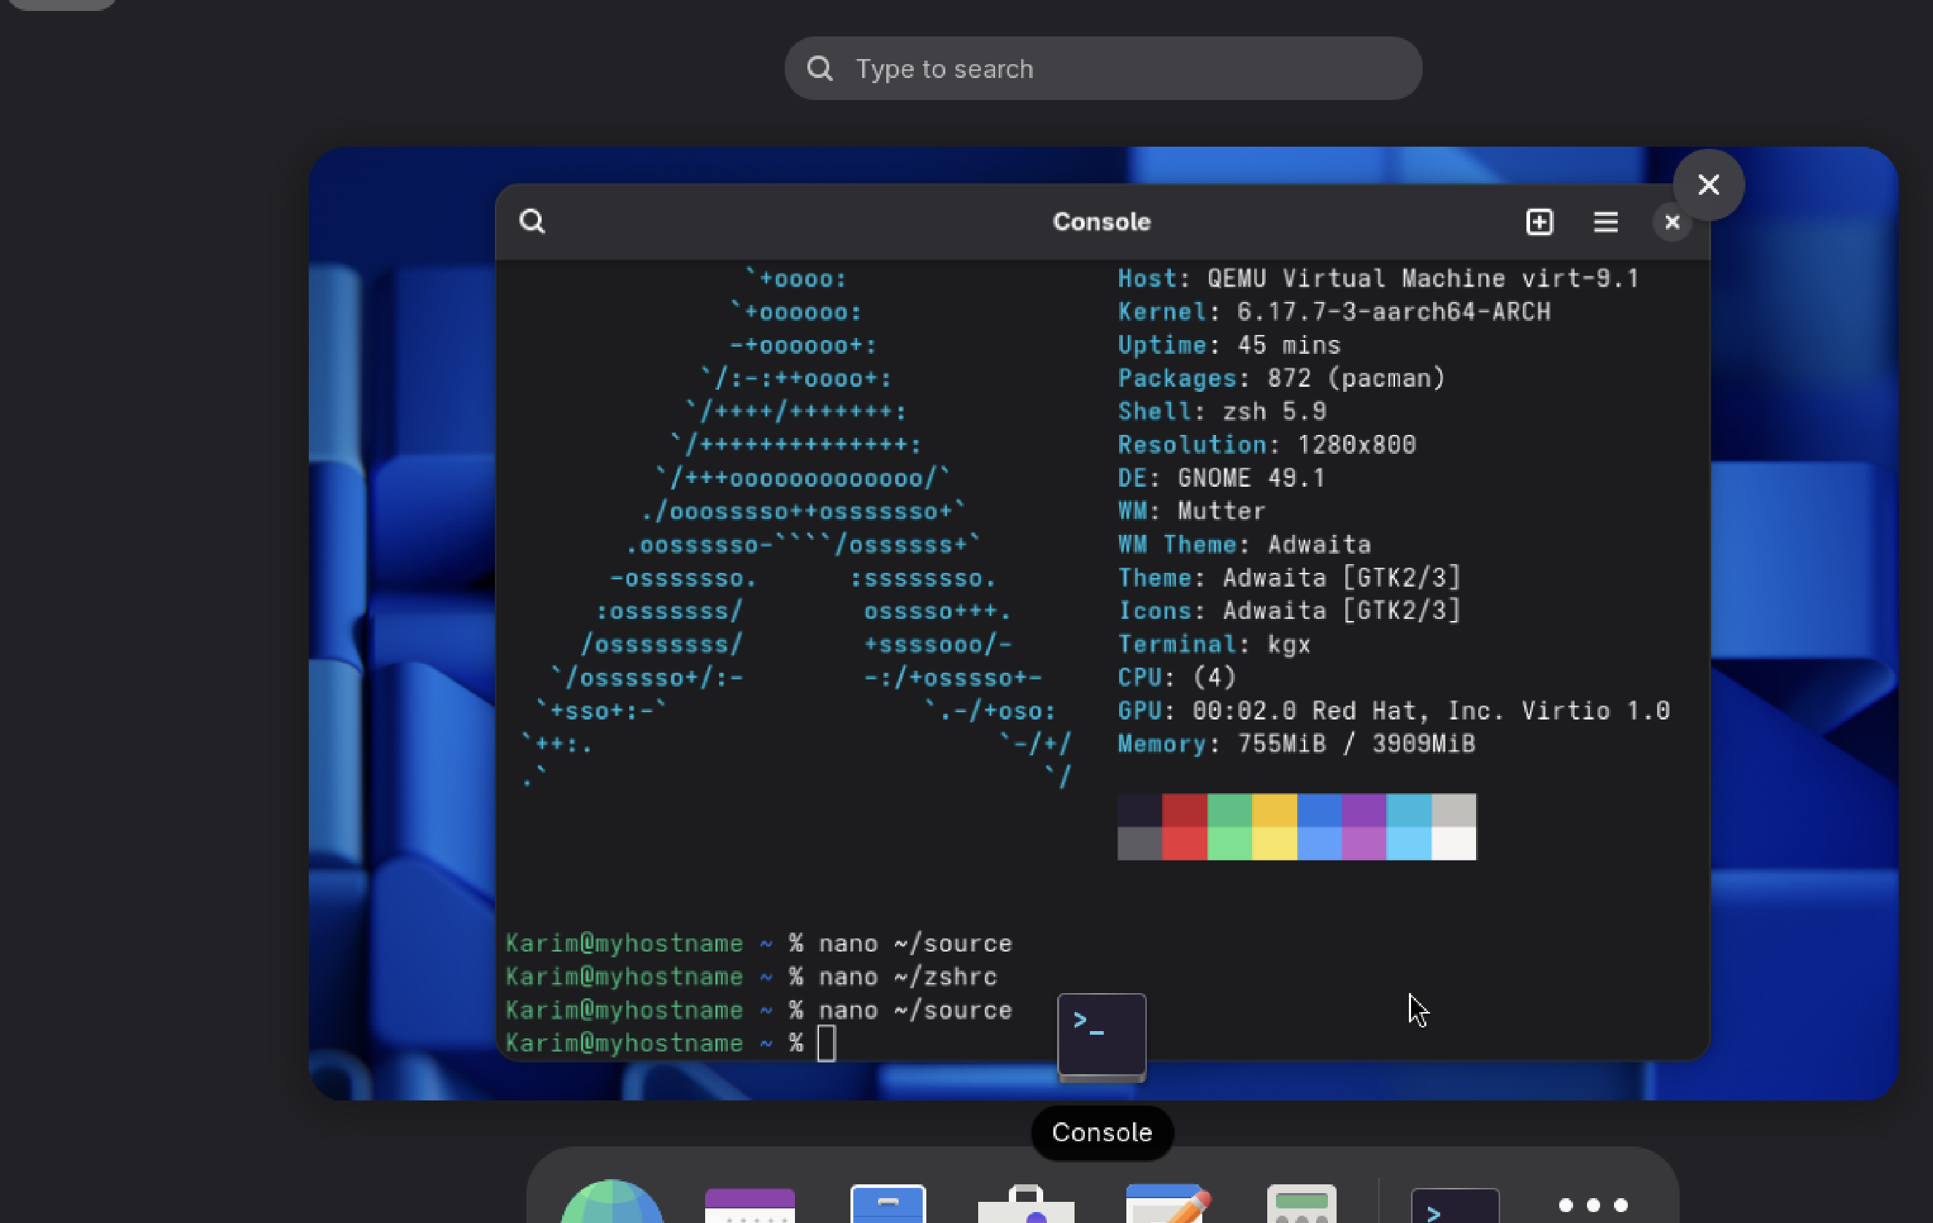

Discussion of Installation Problems

Several issues were encountered during installation and configuration:  
1. Alias errors caused 'command not found' messages — corrected syntax in .zshrc.  
2. Neofetch package not found — fixed by cloning from AUR and building manually.  
3. GPG key verification failed — resolved using 'gpg --recv-keys'.  
4. Sudo permissions adjusted by enabling wheel group in /etc/sudoers.

## Conclusion

The Arch Linux system was installed and customized successfully. Network connectivity, alias configurations, and AUR package installation were verified. The project demonstrates a complete working knowledge of Arch Linux installation, customization, and troubleshooting.